|  |
| --- |
| **Reports Strong Growth and Margin Expansion in Q1FY25**  **Promising Start with 76% Surge in Net Profit**  **Businesses Demerged for Focused Leadership** |

**Pune, India, July 31, 2024:** Deepak Fertilisers and Petrochemicals Corporation Limited (BSE: 500645; NSE: DEEPAKFERT), one of India’s leading producers of industrial & mining chemicals and fertilisers (“DFPCL” or the “Company”), announced its results for the first quarter ended June 30, 2024.

**Consolidated Financial Highlights**

**Q1FY25 Operating EBITDA (Rs. Cr) and Margins (%)**

**Q1FY25 Operating Revenues (Rs. Cr)**

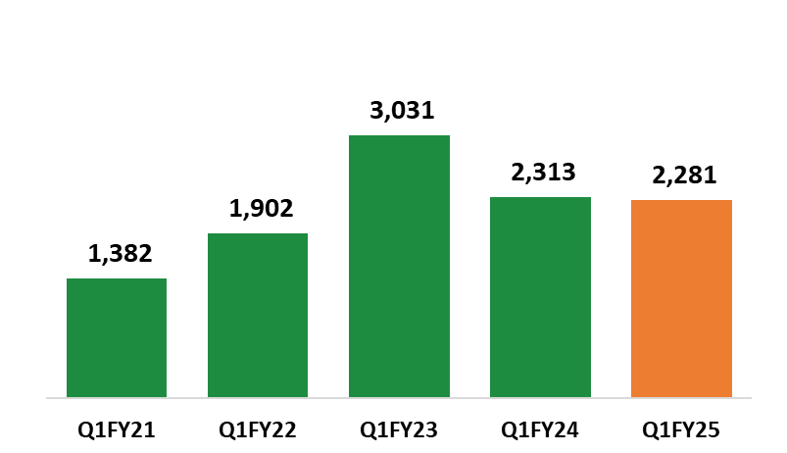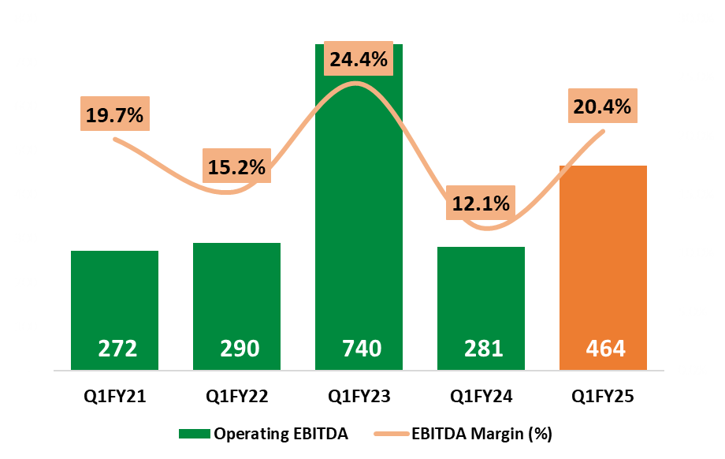

|  |  |  |  |  |  |
| --- | --- | --- | --- | --- | --- |
| **Consolidated**  **(INR CR)** | **Q1FY25** | **Q1FY24^** | **YoY Change** | **Q4FY24\*** | **QoQ Change** |
| Operating Revenue | 2,281 | 2,313 | *(1.4%)* | 2,086 | *9.3%* |
| **Operating EBITDA** | 464 | 281 | *65.5%* | 438 | *6.1%* |
| *Margins (%)* | 20.4% | 12.1% | *823 bps* | 21.0% | *(63) bps* |
| **Net Profit** | 200 | 114 | *75.7%* | 220 | *(9.1%)* |
| *Margin (%)* | 8.8% | 4.9% | *384 bps* | 10.5% | *(178) bps* |

***\*Q4 FY 24 includes other income for Vashi land of Rs.53 Cr and PCL full year incentive of Rs.89 Cr.***

***^Q1 FY 24 has one time impact of 161 Cr of subsidy on channel inventory and warehouse stock.***

|  |
| --- |
| **Key Highlights for Q1FY25:**   * Revenue delivered was Rs.2,281 Crores, marginal decline by 1.4% on YoY basis due to lower commodity prices. * EBITDA margin improved to 20.4% against 12.1% on YoY basis. * PAT was Rs.200 crore which is 76% higher on YoY basis. * Segment Performance:   + - Chemical Segment (Mining and Industrial Chemical) contributed about 57% of total revenue which grew by 5% YoY mainly driven by improved demand in TAN business.     - Fertilisers Segment contributed 43% of total revenue which was lower by 9% YoY because of delay in monsoon which post July has picked up very well. * Reduction in key RM Prices during Q1FY25 has resulted in lower NSP: Ammonia ▼ ~36% YoY; MOP ▼ ~37% YoY; Gas ▼ ~7% YoY ; while delivering improved overall margins. * Launched Croptek grade for Soyabean Crop and Smartek grade for Paddy-& Pulse. * The National Budget has proposed Duty hikes on Ammonium Nitrate and Duty reductions on the Precious Metals used for Catalysts, both will have a positive impact. |
| **Chairman’s Message**  **Commenting on the performance, Mr. Sailesh C. Mehta, Chairman & Managing Director:** |
| |  | | --- | | DFPCL has delivered an impressive performance for Q1FY25, with notable increase in EBITDA margin by 823 bps YoY, up from 12.1% to 20.4%.  The businesses are reaping the benefits of backward integration of Ammonia plant which has helped mitigate supply chain risk as well as price volatility and the benefits are captured within the group.  Also, the strategy of moving from commodity to speciality has been working to sustain and enhance the margins of the businesses.   * Mining chemical segment demonstrated robust volume and margin growth supported by stable imported Fertliser Grade Ammoniam Nitrate (FGAN) prices and lower ammonia prices. The proposed duty hike on ammonium nitrate will also help going forward. * The fertilizer business volume was driven by Croptek and specialty fertilizers, providing crop-specific solutions to farmers. Despite delayed monsoon and high inventory of phosphatic fertilizers, volumes slightly declined by 3% YoY. With rains predicted to be above normal, we expect volume growth in the coming quarter, boosted by new launches: Croptek grade for Soyabean and Smartek for paddy and pulses. * Margins of Nitric acid are stable with volumes lower on YoY basis due to extended repair in WNA plant. The IPA business declined by 8% YoY due to the planned shutdown of the plant. Going forward, we expect stable demand in both Nitric Acid and IPA segment.   Hon'ble National Company Law Tribunal (NCLT), Mumbai, has approved demerger plan for the Mining Chemicals and Crop Nutrition businesses. This strategic restructuring is a step towards achieving our vision of transitioning from Commodity to Specialty and moving from Customer to Consumer by providing holistic solutions, driven by specific business strategy, market leadership, technology and operational focus.  Further, as indicated by the national budget and the government’s continued focus on critical sectors such as agriculture, power, mining, and infrastructure, which is promising for the company from both short-term and long-term perspectives.  We continue to maintain sharp focus on operational efficiences, drive cost optimizations, capacity utilization, and productivity improvements, which will help us navigate through market challenges and remain steadfast in adding value to our shareholders. | |  |     **Chemicals Review** |

* **Mining Chemicals (Technical Ammonium Nitrate):**
* Mining Chemical business delivered an outstanding quarter; outlook remains positive supported by growth in Mining and Infrastructure sector.
* In Q1FY25, Technical Ammonium Nitrate sales volume surged by 23% YoY mainly due to improved demand.
* The quarter witnessed positive trends across key market indicators compared to the high base of Q1FY24. All-India coal production increased by 11% YoY, and steel sector production grew by 11% YoY.
* Post demerger, the Mining Chemicals business will operate as a separate legal entity, establishing itself as a fully integrated with unique value chain offering technology solutions to its customers in India.
* Business Outlook: Demand is expected to remain strong over the next couple of quarters driven by growth in coal mining, power, and infrastructure sectors.
* **Industrial Chemicals:**
* In Q1 FY25, nitric acid volumes decreased by 12% YoY. The YoY decline was attributed to an extended repair job at Taloja Acid plant and reduced demand from downstream industries following the temporary shutdown of the GNFC TDI plant leading to a short term oversupply.
* IPA volumes are down owing to planned shutdown in Q1FY25. Our speciality pharma grade IPA continued to grow.
* Speciality Stainless Steel grade Nitric acid has witnessed positive customer response since its commercial launch.
* Business Outlook: Nitric acid prices are expected to gradually improve over next few quarters. Propylene based IPA would continue to perform better from demand and price perspective. Further, various trials at customers end are being conducted for stainless steel grade nitric acid and we expect expansion of volumes. Our Speciality Chemicals are expected to grow, with the Steel Grade Nitric Acid and Pharma Grade IPA having strong and positive acceptance by the end customers.

**Crop Nutrition Business (Fertilisers) Review**

* During the quarter, sales of manufactured bulk fertilisers was 174 KMT, representing an 11% increase YoY.
* The company has launched Smartek fertilizer for paddy, pulses, and cotton, along with the Croptek grade for soybean crops
* Sales of specialty fertilizer product, Bensulf, amounted to 10 KMT this quarter, reflecting a 51% increase YoY.
* Sales of traded specialty fertilisers in Q1FY25 saw an 80% increase YoY. With global prices for water-soluble fertilisers stabilizing, demand has now returned to normal levels.
* Business Outlook: With better monsoon, the demand outlook is positive. We are focusing on on delivering crop specific and water soluble fertilizers which deliver higher yield and productivity to the farmer. Additionally, our recent partnership with Israel-based Haifa Group will help to promote high-performance specialty fertilisers.

**Company Overview**

**Deepak Fertilisers and Petrochemicals Corporation Ltd. (DFPCL)** is among the India’s leading manufacturers of industrial chemicals and fertilisers. With a strong presence in Technical Ammonium Nitrate (mining chemicals), Industrial Chemicals and Crop Nutrition (fertilisers), the Company supports critical sectors of the economy such as infrastructure, mining, chemicals, pharmaceutical and agriculture. DFPCL is a publicly listed, multi-product Indian conglomerate and has plants located in four states, namely Maharashtra (Taloja), Gujarat (Dahej), Andhra Pradesh (Srikakulam) and Haryana (Panipat).

DFPCL is Leading manufacturer and marketer of Iso Propyl Alcohol (IPA) in India and Largest Manufacturer of Nitric Acid in Southeast Asia. The Company is developing specialised grades of Nitric acid and IPA to meet specific requirements to cater needs of the industry/consumer.

DFPCL is one of the leading manufacturers of Technical Ammonium Nitrate in the world, it is the only producer of prilled Technical Grade Ammonium Nitrate solids and medical grade Ammonium Nitrate in India. The Company has commenced best in-class Technical Services to drive downstream productivity benefits for the mining end consumers.

CNB Segment (fertilisers) offers a basket of 48 products which include bulk fertilisers, Crop nutrient solutions, specialty fertilisers, water-soluble fertilisers, bio-stimulants, micro-nutrients, and secondary nutrients, catering to every crop’s nutrient requirement. Enhanced-efficiency speciality fertilisers are developed basis rigorous R&D efforts and product trials at over 50,000 farmer demo plots. The R&D efforts have shown distinct yield and quality improvements for crops across segments such as cotton, sugarcane, onion, fruits and vegetables. Over last three years, value-added nutrition products have benefitted 6 million farmers.

**Safe Harbour:**

This document contains statements that contain “forward looking statements” including, but without limitation, statements relating to the implementation of strategic initiatives, and other statements relating Deepak Fertilisers and Petrochemicals Corporation Limited’s (DFPCL) future business developments and economic performance. While these forward looking statements are neither predictions nor guarantees of future events, circumstances or performance and are inherently subject to known and unknown risks and uncertainties, are based on management belief as well as assumptions made by and information currently available to management and only indicate our assessment and future expectations concerning the development of our business, a number of risks, uncertainties and other unknown factors could cause actual developments and results to differ materially from our expectations. These factors include, but are not limited to, general market, macro-economic, governmental and regulatory trends, movements in currency exchange and interest rates, competitive pressures, technological developments, changes in the financial conditions of third parties dealing with us, legislative developments, and other key factors that could affect our business and financial performance. DFPCL undertakes no obligation to publicly revise any forward looking statements to reflect future / likely events or circumstances.