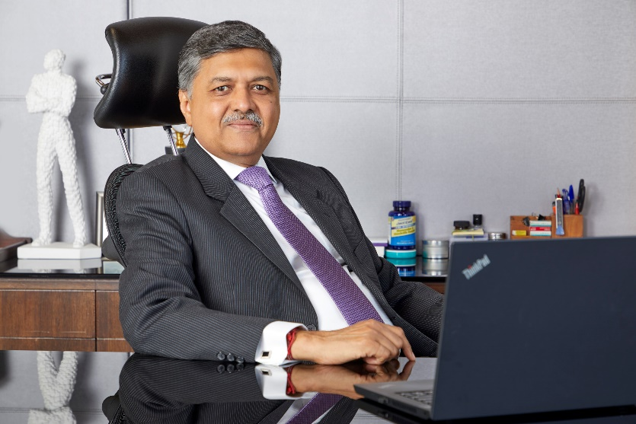

**Sailesh C. Mehta elected Chairman  
 of the Fertiliser Association of India**

* **The Fertiliser Industry serves over 14 crore farmers.**
* **Delivered over Rs. 982 billion (USD 11.51 billion) in 2024 in Annual Revenues**

Fertiliser Association of India (FAI), the body representing the country’s Fertiliser Industry comprising of Public Sector, Joint Sector & Private Sector entities elected Mr. Sailesh C Mehta, Chairman & Managing Director, Deepak Fertilisers and Petrochemicals Corporation Ltd & Mahadhan AgriTech Ltd, as its new Chairman.

With over four decades of experience in the industry, Mr. Mehta also served as Chairman of the Fertiliser Association of India (Western Region) for over five years

The Fertiliser Industry has played a pivotal role in driving India’s agricultural growth output by 60% and horticulture output by 40% over the last two decades. The industry benchmarks its operational efficiencies among the Global best and plays a vital role in the effective delivery of subsidized fertilisers to millions of Indian farmers.

On the occasion, Mr. Metha said “India’s journey from food scarcity to global agri-exporter has been remarkable. The Fertiliser Industry continues to play a vital role in this journey, now with a focus on more balanced and nutrient-efficient fertilisers that supports sustainable growth.

I am truly privileged to serve as a bridge between Government, Industry and our farmers – acting as a catalyst to elevate Indian Farmer and Farm productivity on the World Map”.